Assignment 1

Implement the CNN model for colored images

To implement the CNN model with colored images we use an RGB image where the number of channels will be 3 which are red, blue and green.
We do not give the cmap, to get the image as it is i.e colored.

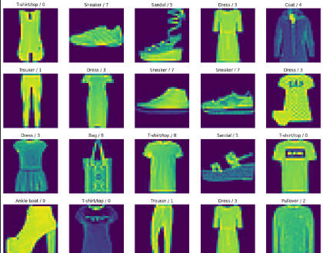

Assignment 2
The effect of accuracy and model loss by changing the number of epoch,batch size and learning rate

- epoch=10, batch_size=512, learning_rate=0.001
Observation
- Stable training
- Moderate accuracy
- Smooth loss curve
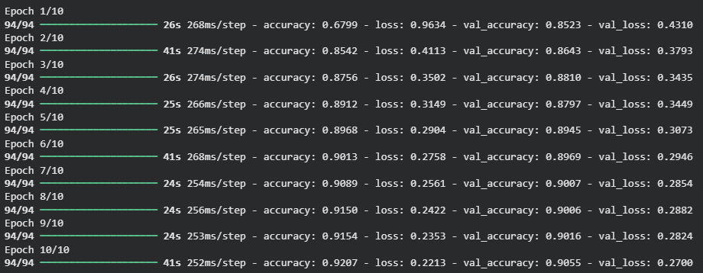

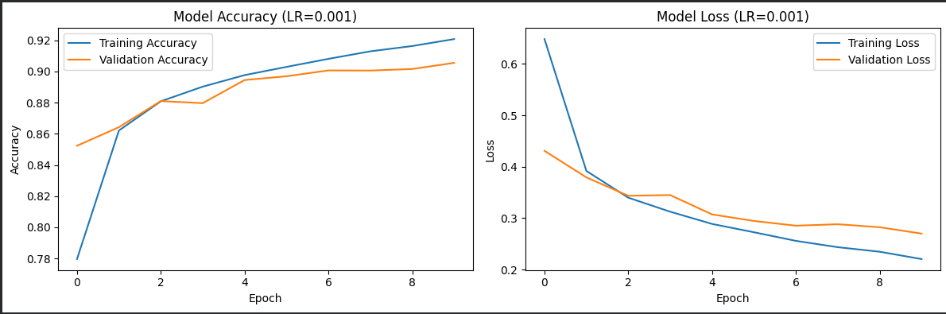

- epoch=20, batch_size=512, learning_rate=0.001
Observation
- Training accuracy increases
- Validation accuracy may increase slightly
- Risk of overfitting after some epochs

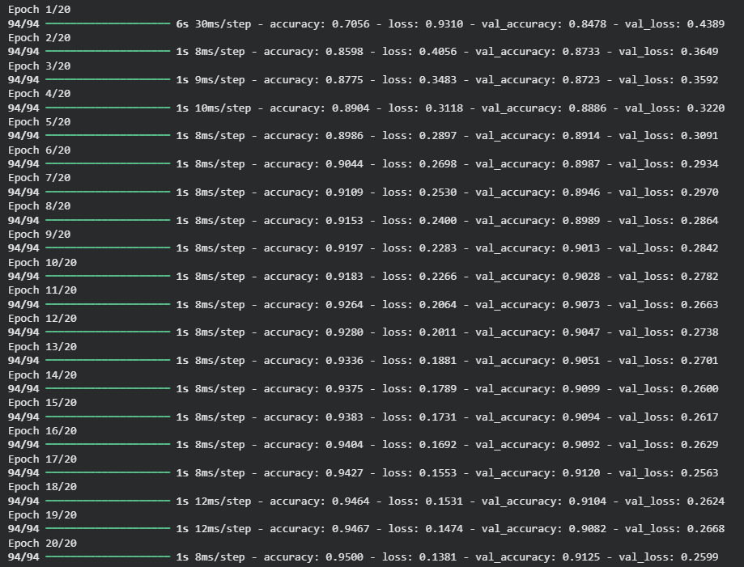

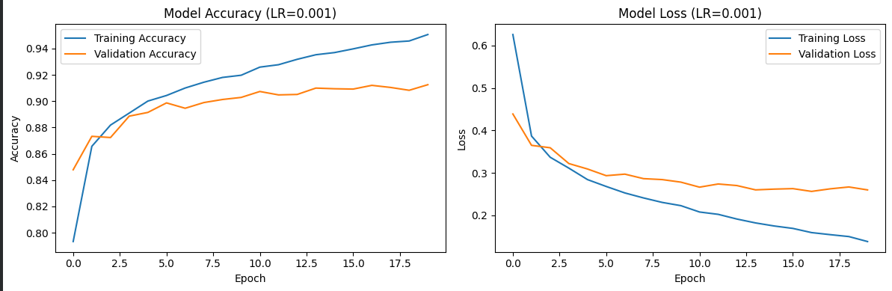

- epoch=10, batch_size=64, learning_rate=0.001
Observation
- More frequent weight updates
- Slower training
- Often better generalization
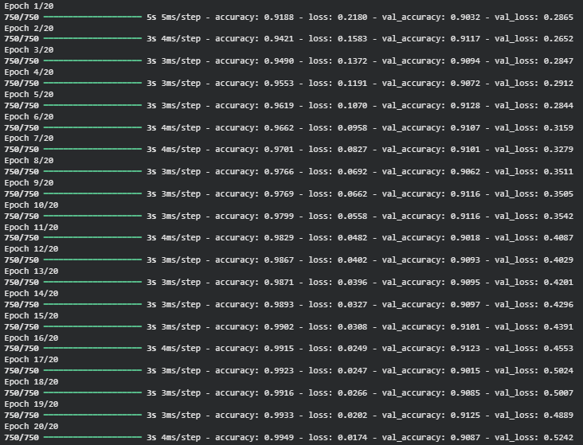

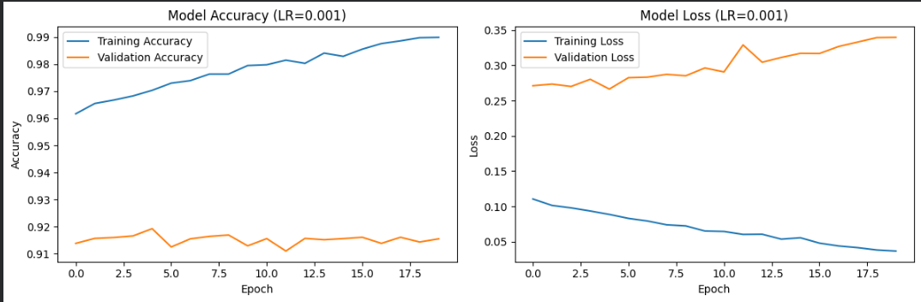

- epoch=10, batch_size=512 ,learning_rate=0.01
Observation
- Unstable training
- Loss may oscillate or increase
- Accuracy fluctuates
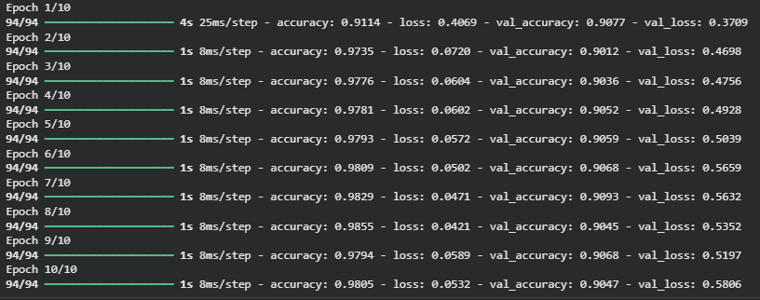

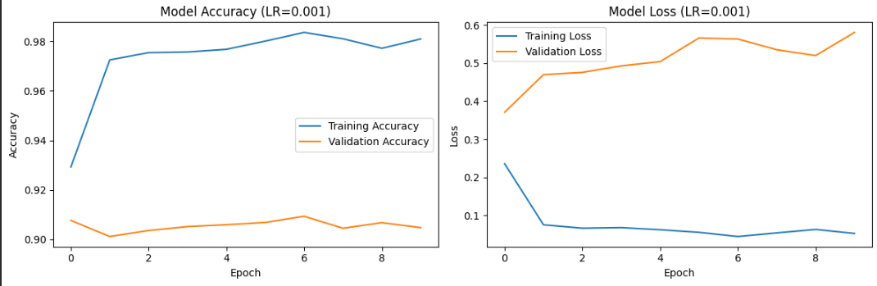

- epoch=10, batch_size=512,learning_rate=0.0001
Observation
- Very slow learning
- Needs more epochs
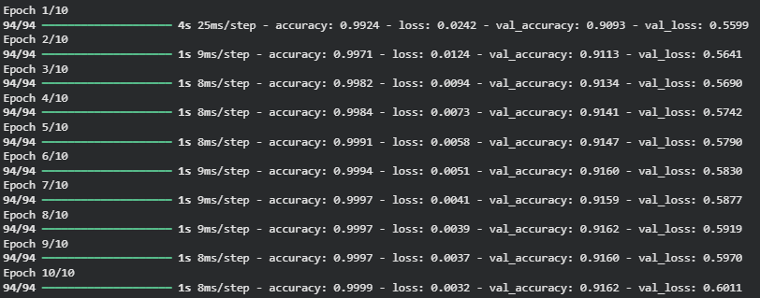

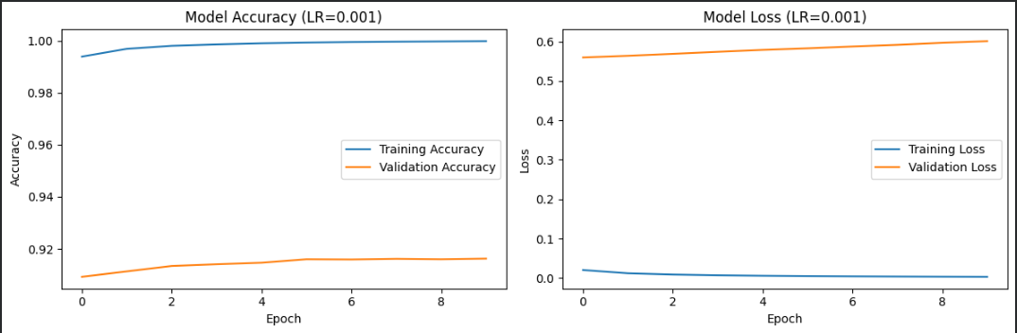

Assignment 3
Implement the same with other dataset
I used the dataset cifar10
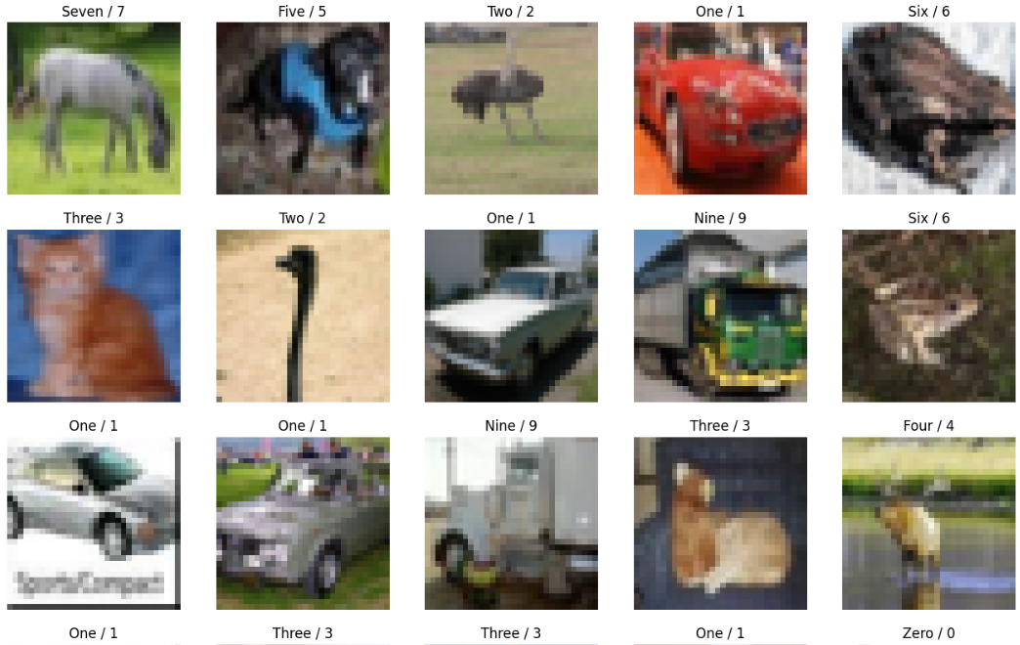
The accuracy was very low for this because this dataset requires more tuning and it also requires regularization.
In order to have better accuracy I increased the number of epochs so that the model can learn better.

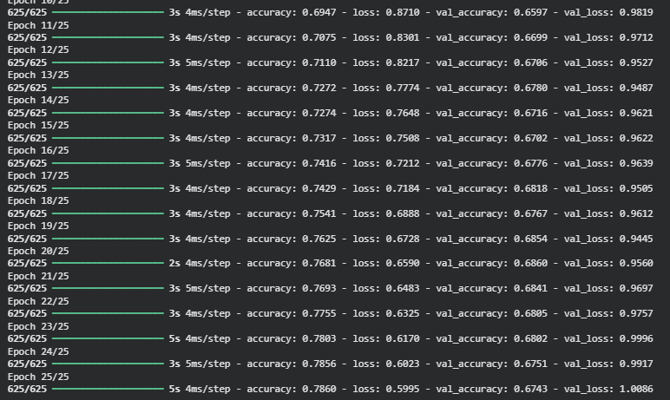

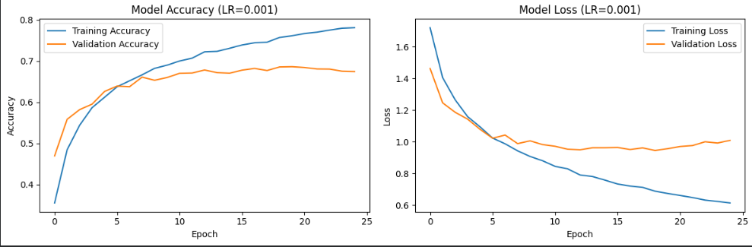

Output for test data:
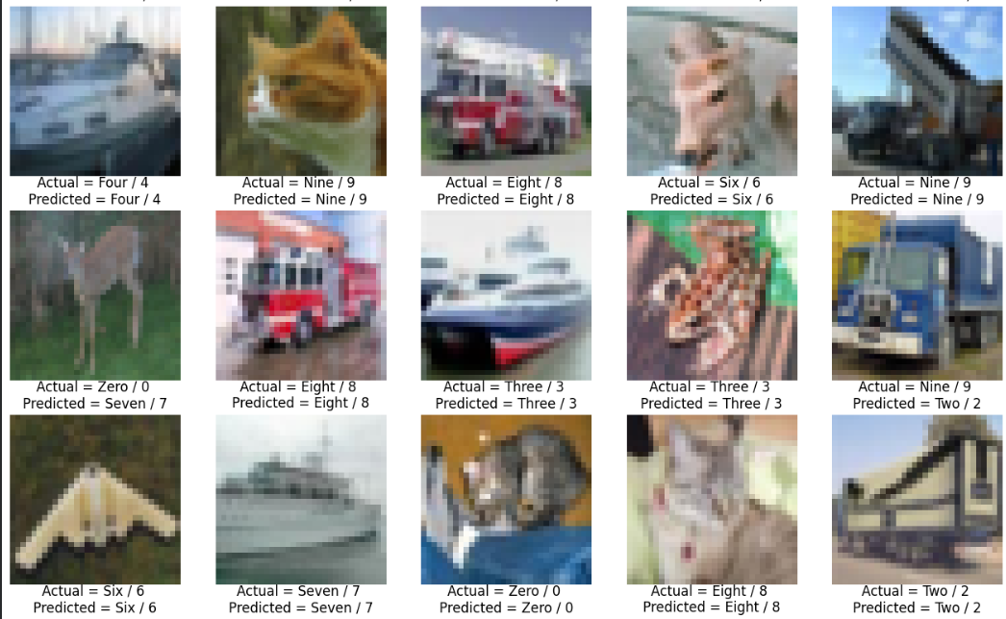

Assignment 4
Increasing the number of layers from 3 to 5

As the layers increased the accuracy of the model also increased
